**TY B.Tech. (CSE) – II [ 2022-23 ]**

**5CS372 : Advanced Database System Lab.**

**Assignment No. 9**

**PRN: 2020BTECS00069**

**Yashraj Patil**

**Install & deploy the following cloud databases on windows platform :**

**Write Python desktop Application to demonstrate the CRUD operation with above backend cloud databases.**

**A] MongoDB**

Install MongoDB On Windows

* Download the latest version of MongoDB from the official website: <https://www.mongodb.com/try/download/community>
* Run the installer and choose the "Complete" installation option.
* Accept the license agreement and choose the installation directory. The default directory is C:\Program Files\MongoDB\Server\{{version}}.
* Choose the options to install MongoDB as a Windows service and to start the service automatically.
* Click on "Install" and wait for the installation process to complete.
* Once the installation is complete, navigate to the MongoDB installation directory in a command prompt. For example, if you chose the default installation directory, you would run:
* cd C:\Program Files\MongoDB\Server\{{version}}\bin
* where {{version}} is the version of MongoDB you installed.
* To start the MongoDB server, run the following command:

mongod.exe

* The MongoDB server should start running and output logs to the console. Keep the console window open while you use MongoDB.
* To interact with MongoDB, open another command prompt and navigate to the MongoDB installation directory's bin folder, as shown in step 6.
* Run the following command to start the MongoDB shell:
* Copy code
* mongo.exe
* You should now be able to use the MongoDB shell to interact with MongoDB.  
    
  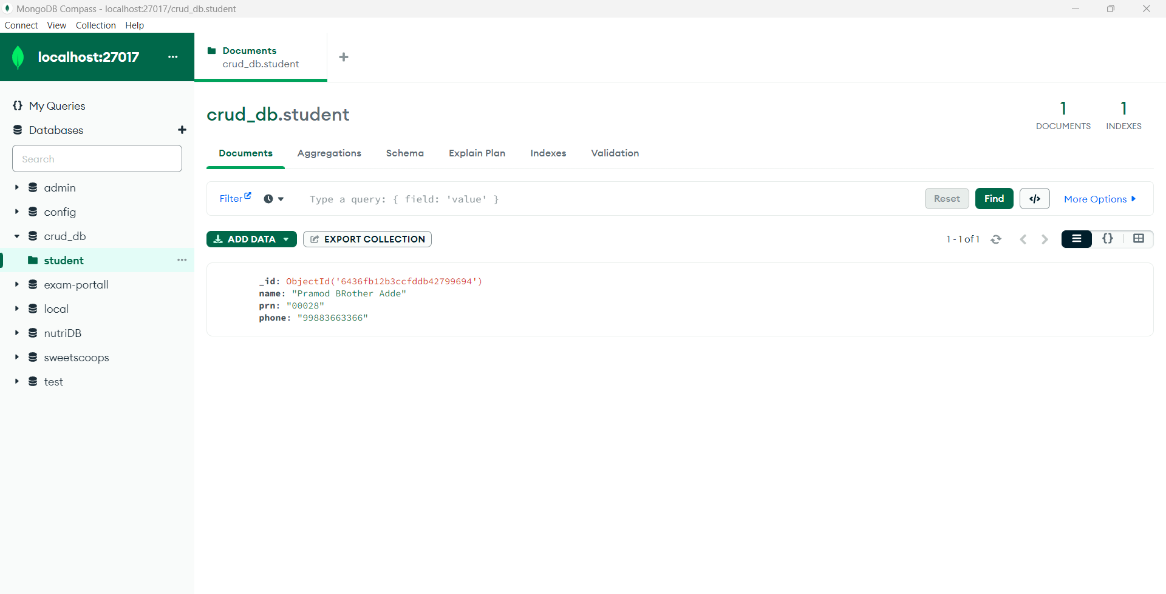  
  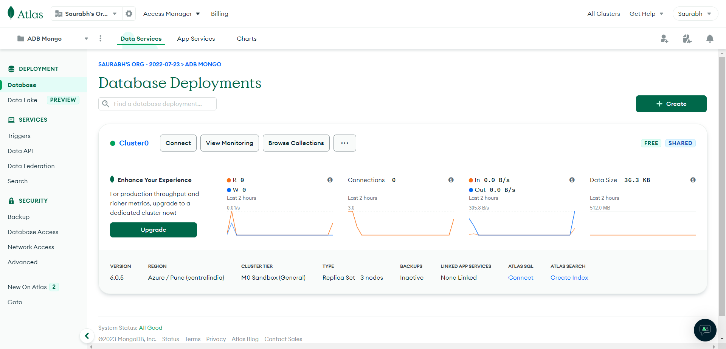

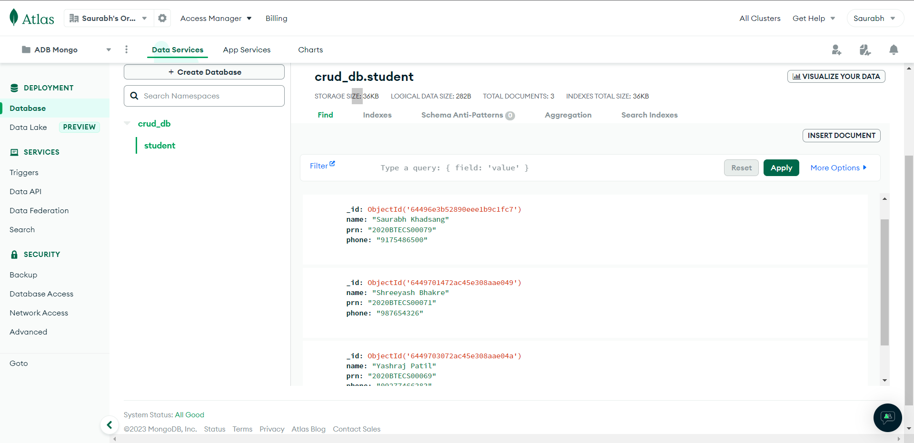

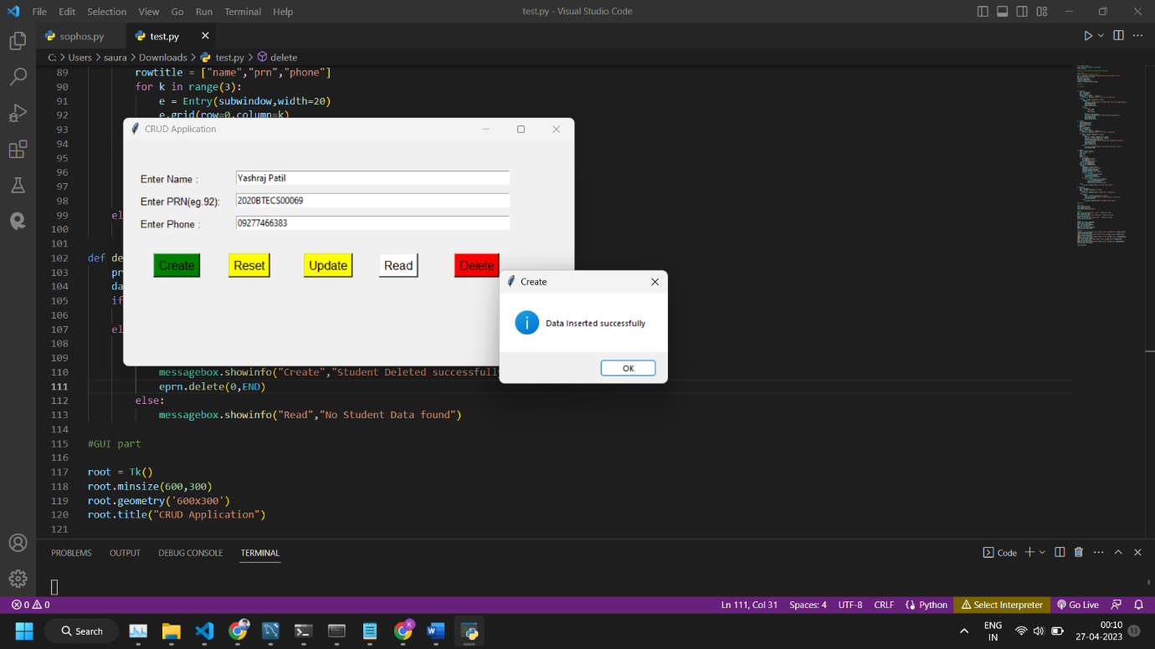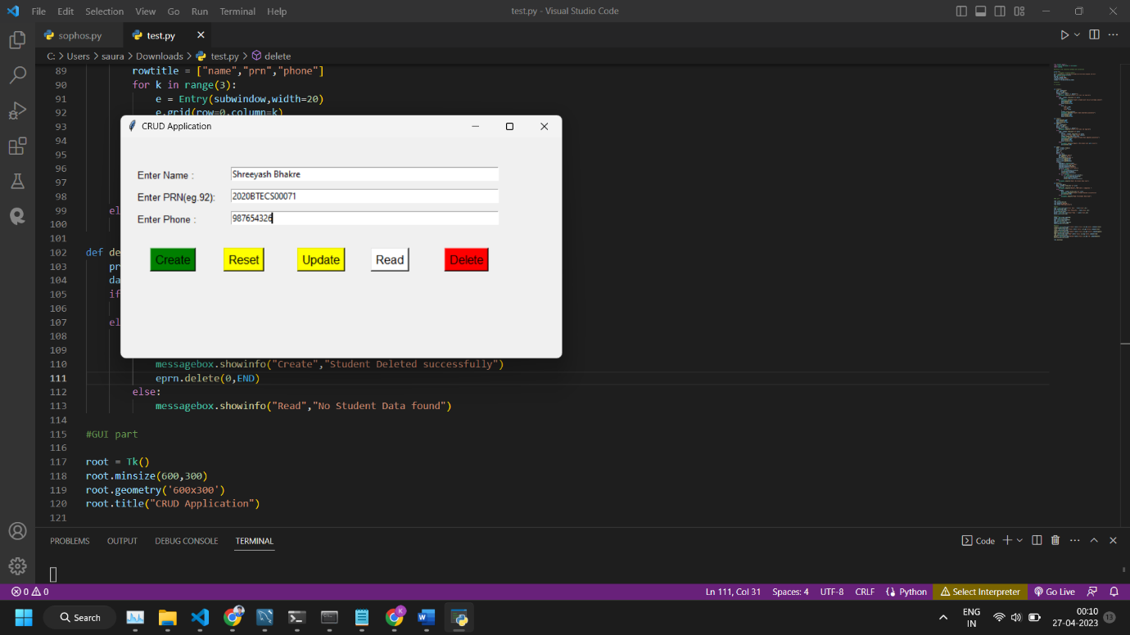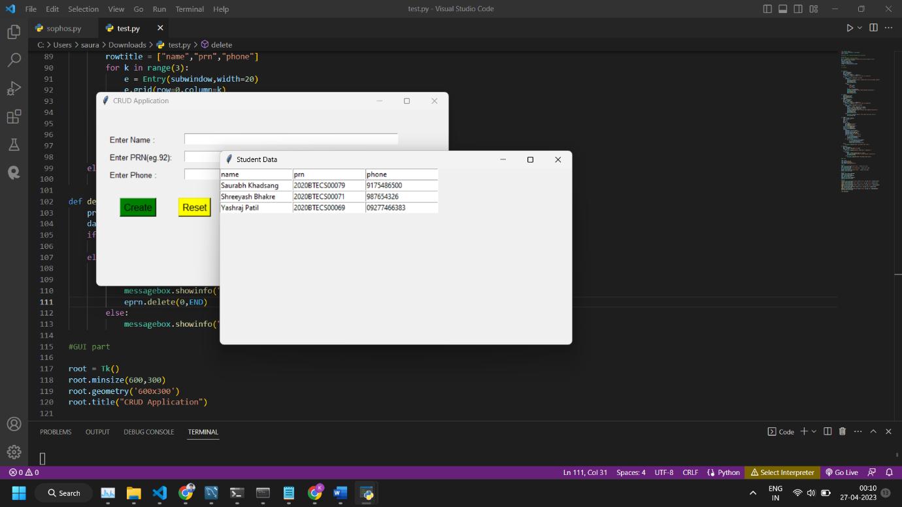

**B] CassandraDB**

Install CassandraDB On Windows

* Download the latest version of Apache Cassandra from the official website: <https://cassandra.apache.org/download/>
* Extract the downloaded archive to a folder of your choice,

e.g. C:\apache-cassandra-3.0.28.

* Add the C:\apache-cassandra-3.0.28\bin directory to your system's PATH environment variable. This will allow you to run Cassandra from any command prompt.
* Open command prompt and run the following command to star Cassandra:

Wait for Cassandra to start up. You should see some output in the command prompt window indicating that Cassandra has started.

* Run the following command to start the Cassandra command-line interface (CLI):

You should now be able to use the CLI to interact with Cassandra.

* That's it! You now have Apache Cassandra installed and running on your Windows system.

